AMAZON AWS AND JENKINS ASSIGNMENT

21A95A0414

Q1) Build a manual ci-cd pipeline for a java application and also write a simple test.sh for testing, after that convert the same in automated ci-cd pipeline using jenkins but you have to also use maven for java application.

MANAGE JENKINS

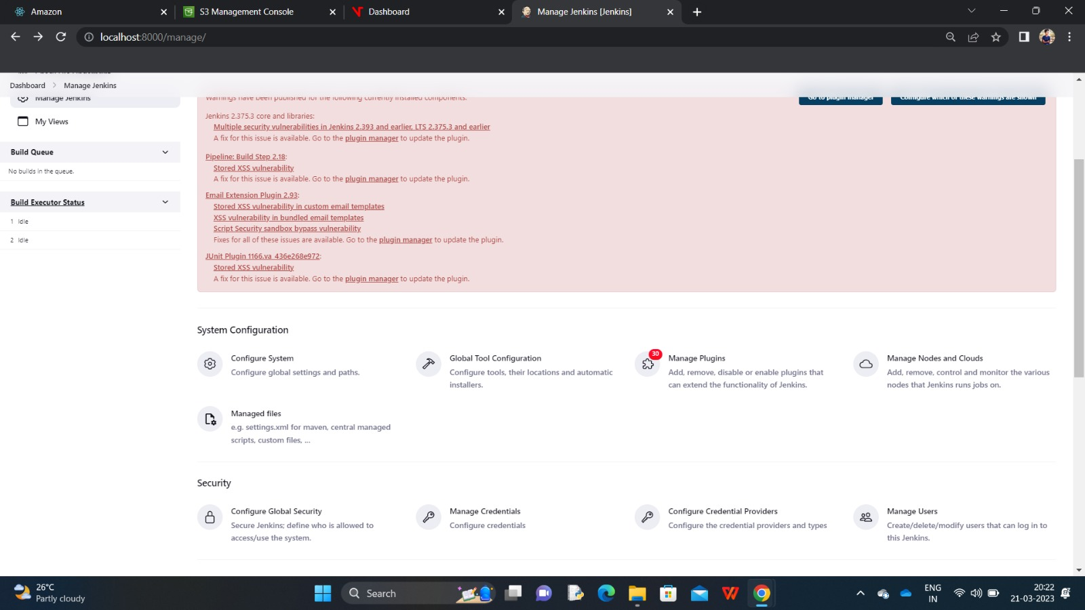

INSTALLING PLUGLINS->MAVEN INTEGRATION AND MAVEN PIPELINE INTEGRATION

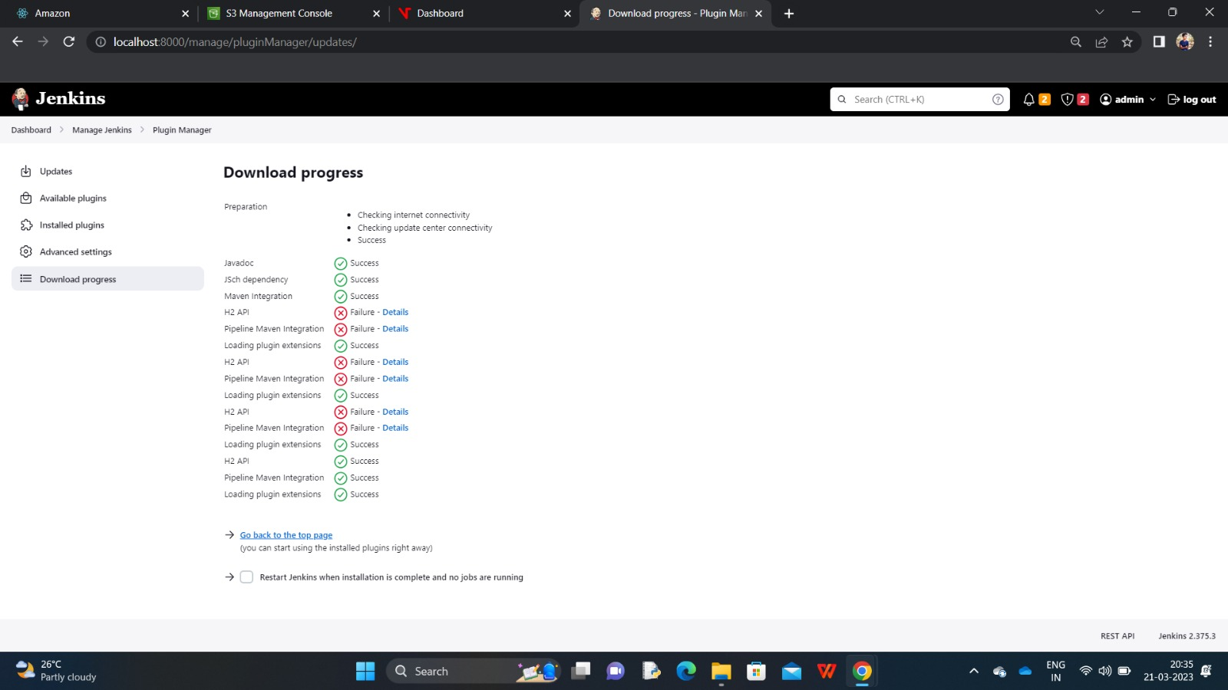

CONFIGURE SETTINGS

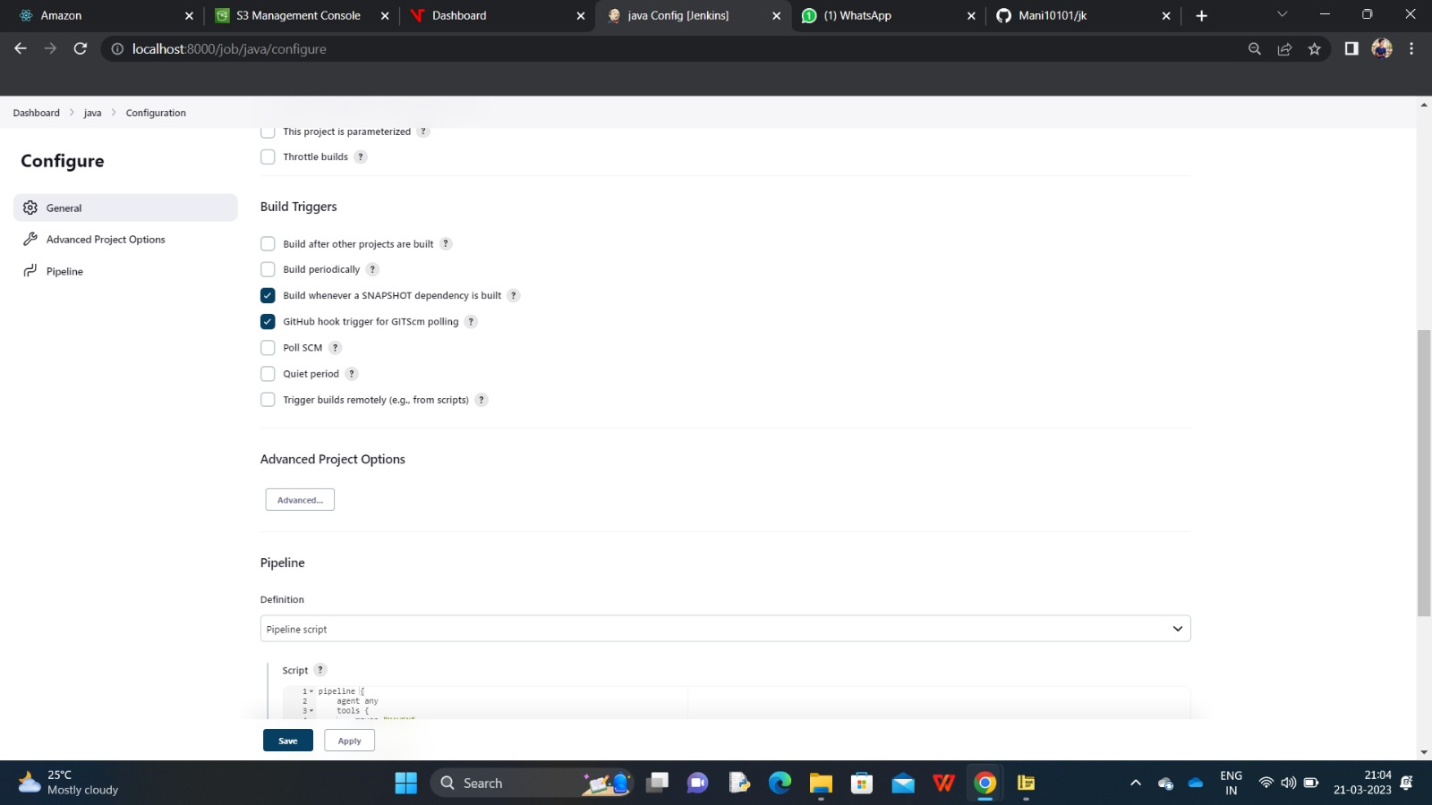

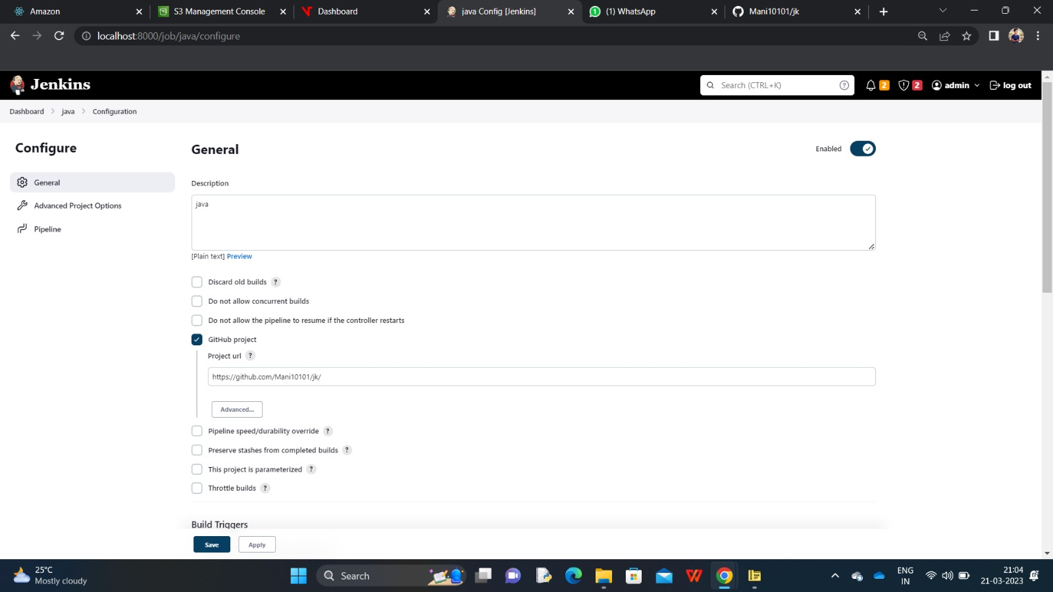

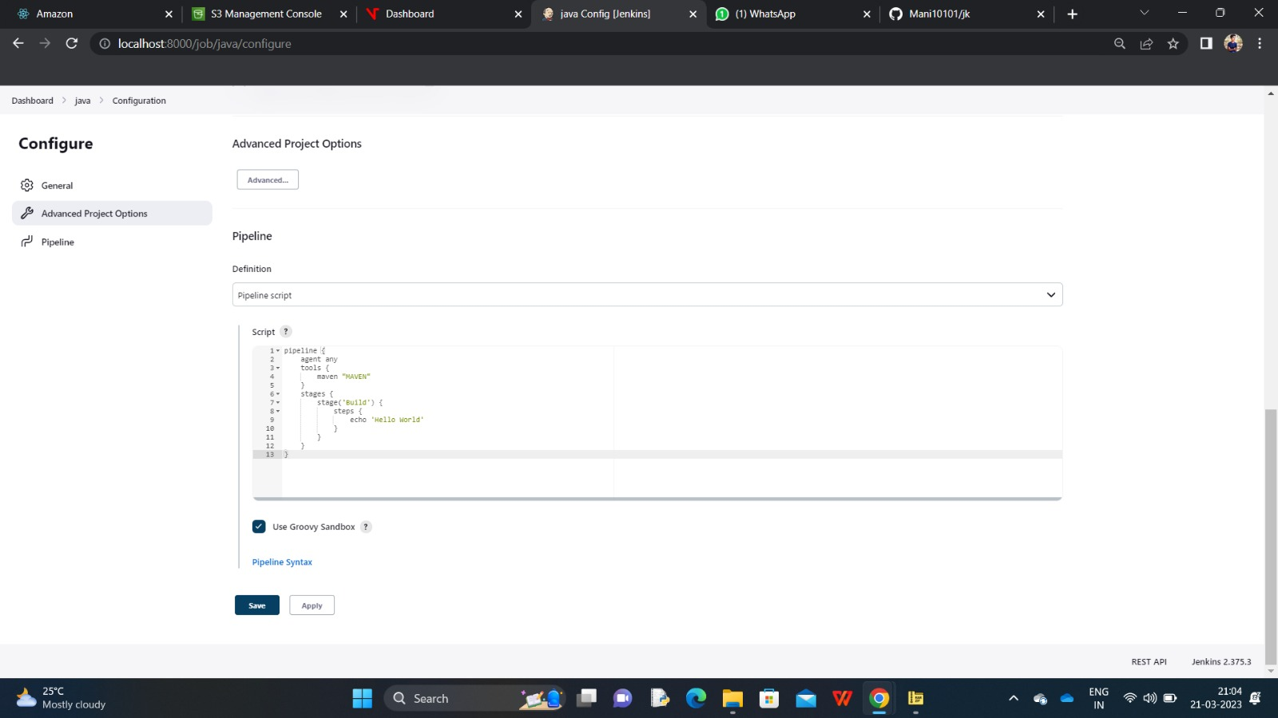

GLOBAL TOOL CONFIGURATIONS SETTINGS

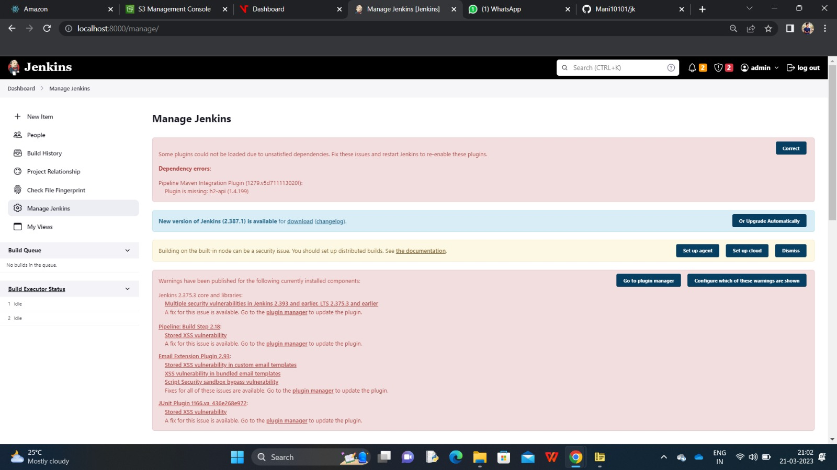

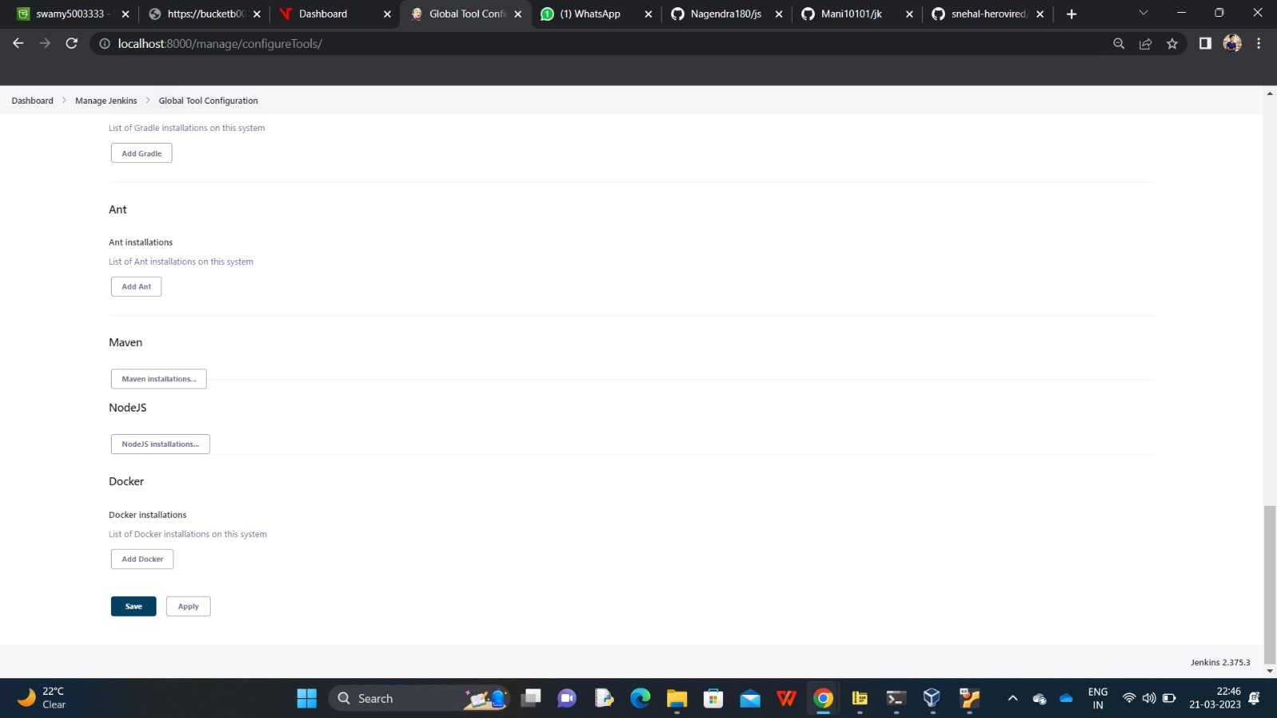

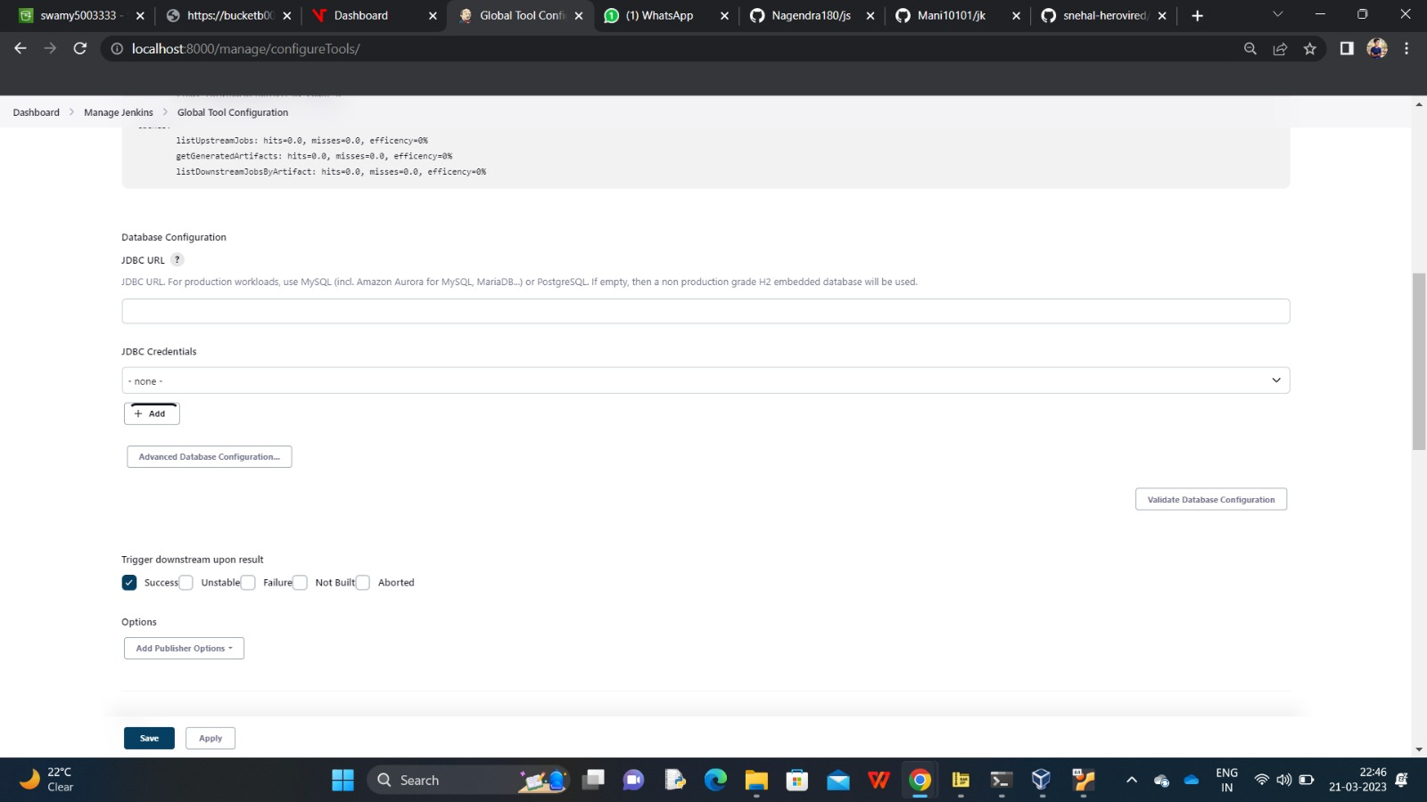

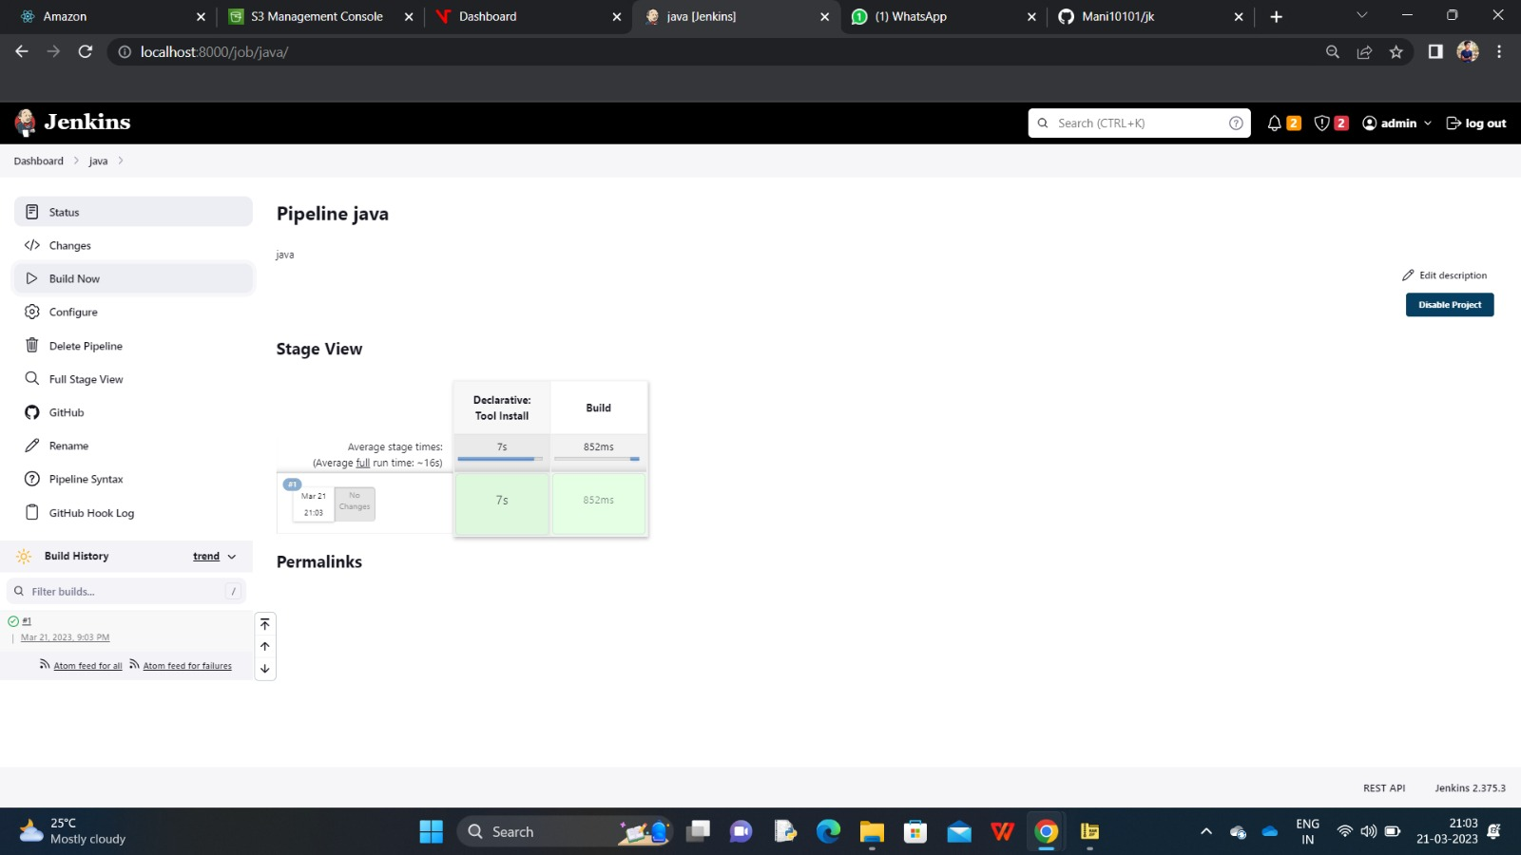

Q2) Create an EC2 instance for a REACTJS application and deploy the application and provide the public IP for it, also enable the cloud monitoring on these instances.

INSTANCE WITH UBUNTU IMAGE

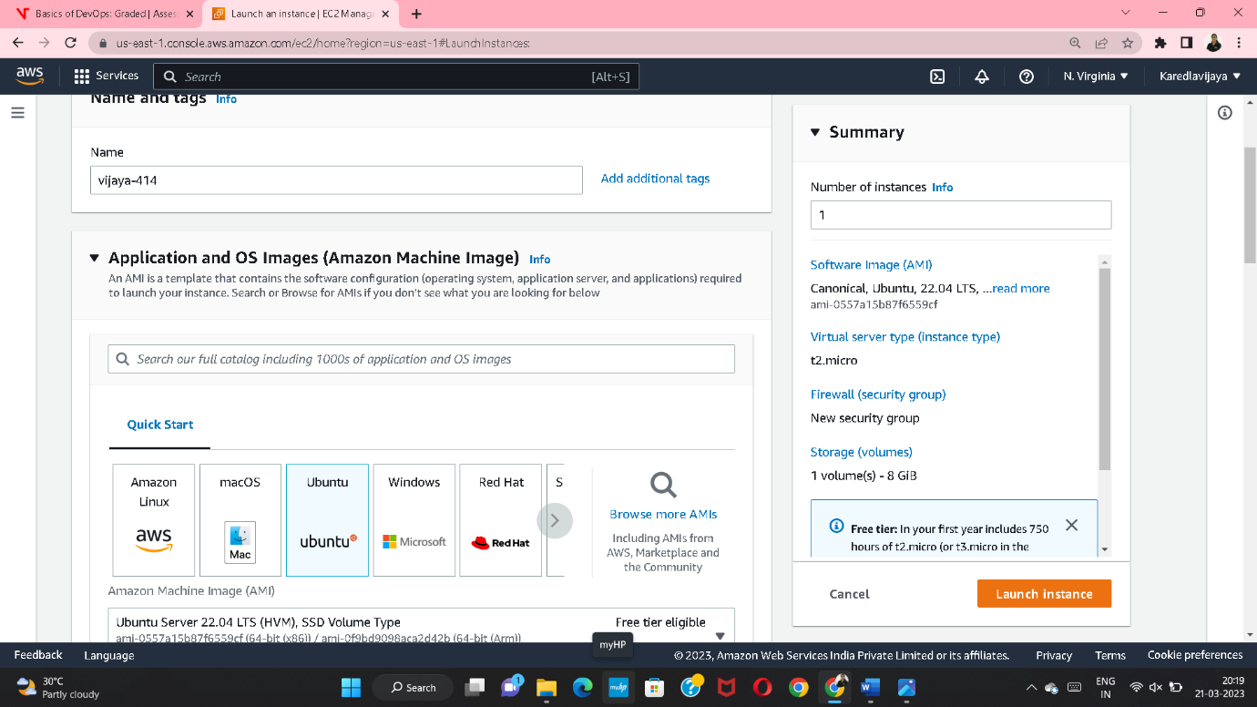

RUNNING INSTANC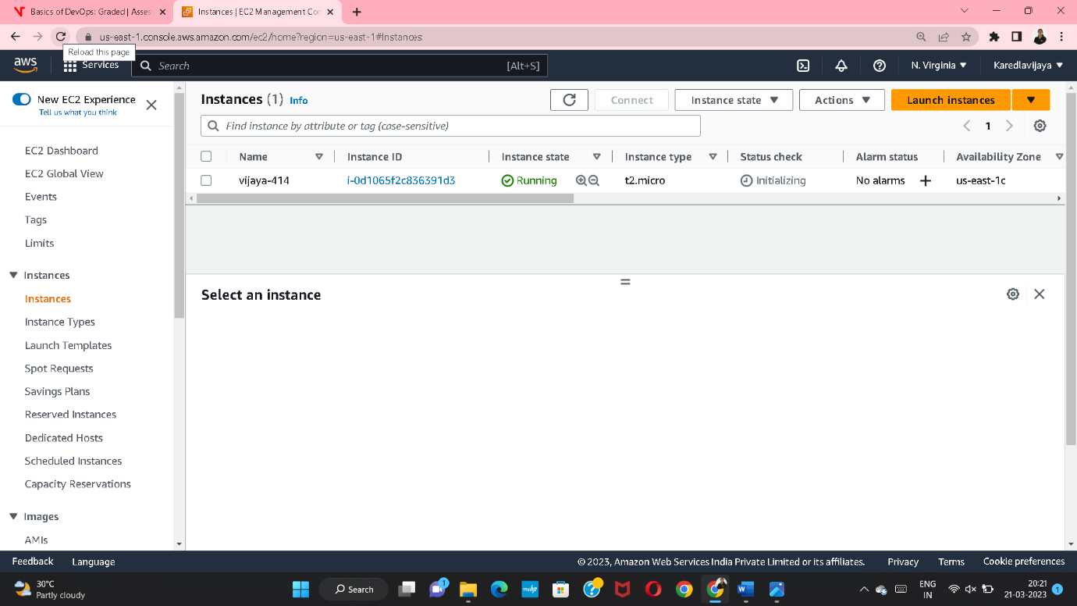E

AFTER CONNECTING THE INSTANCE 🡪COMMANDS

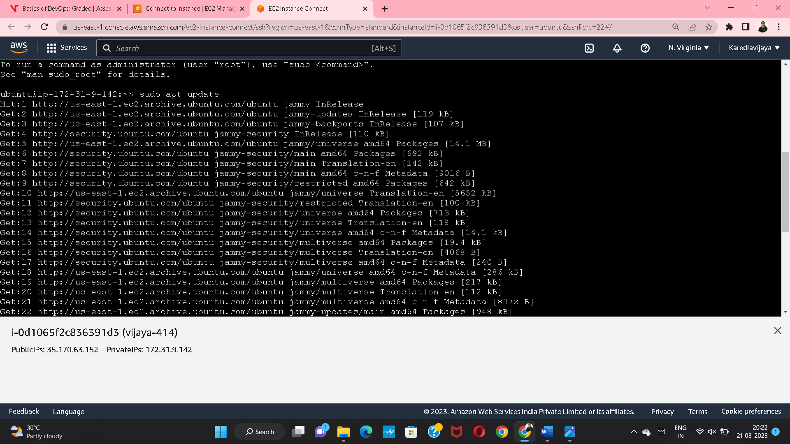

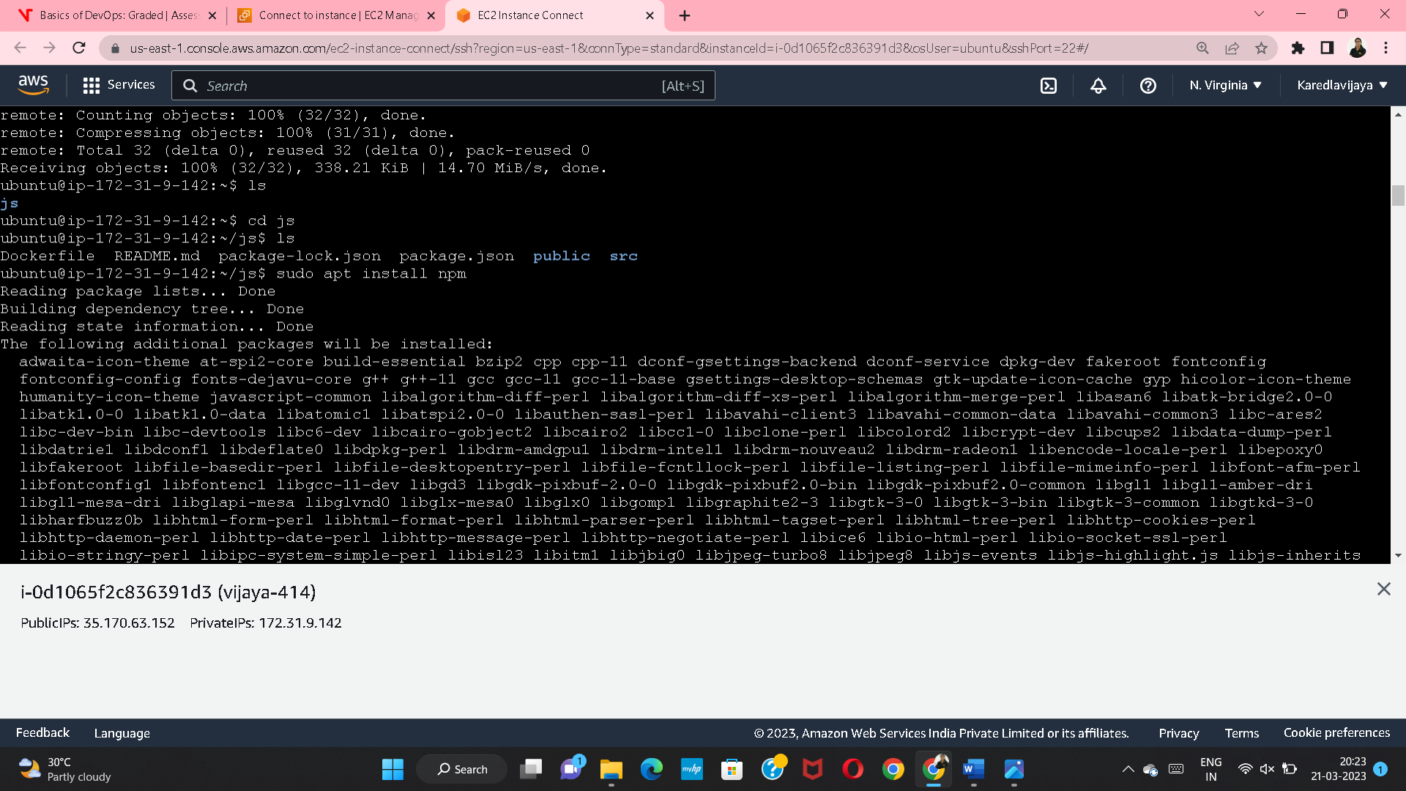

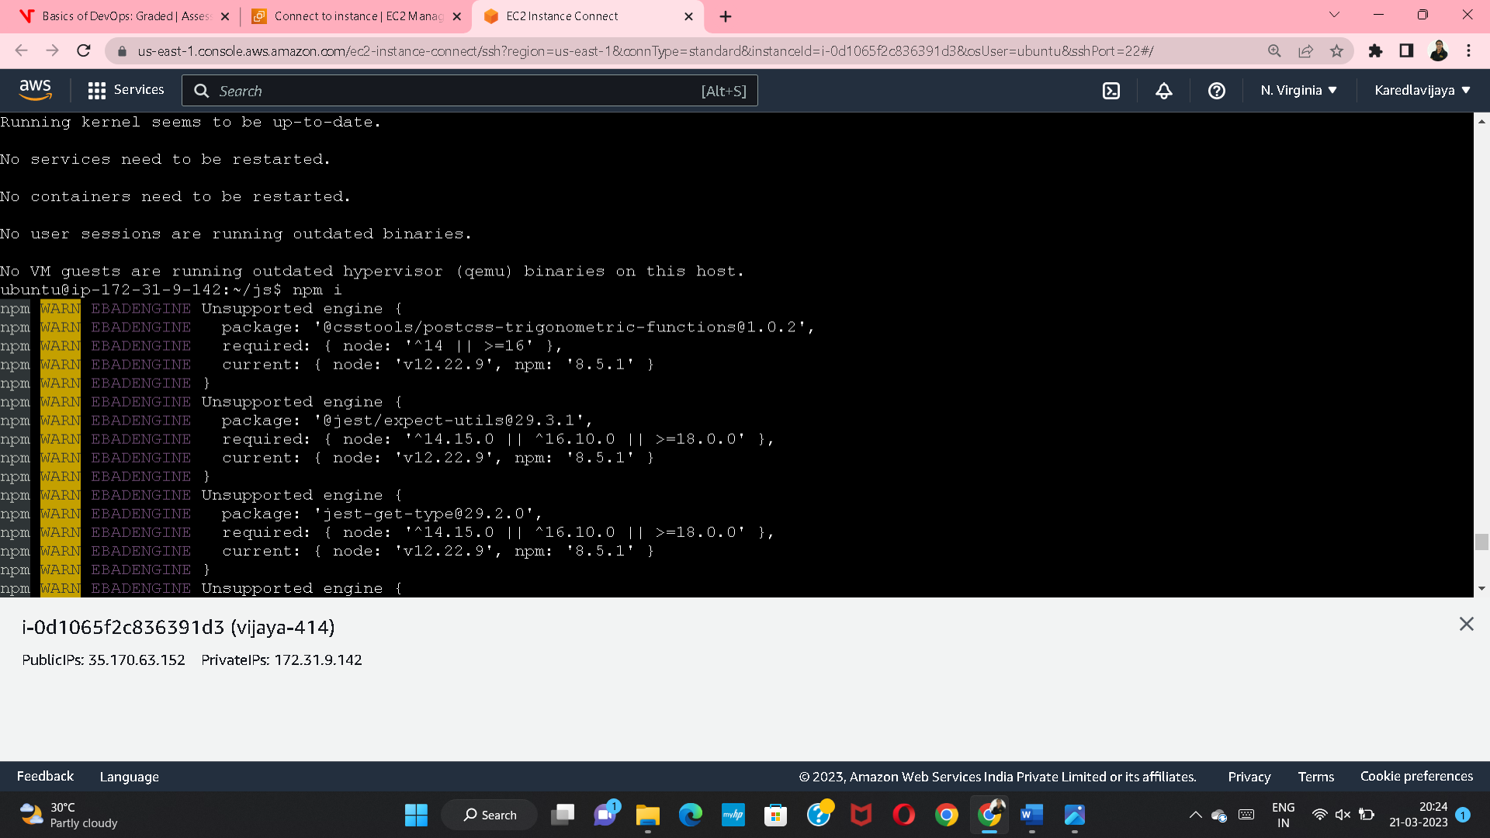

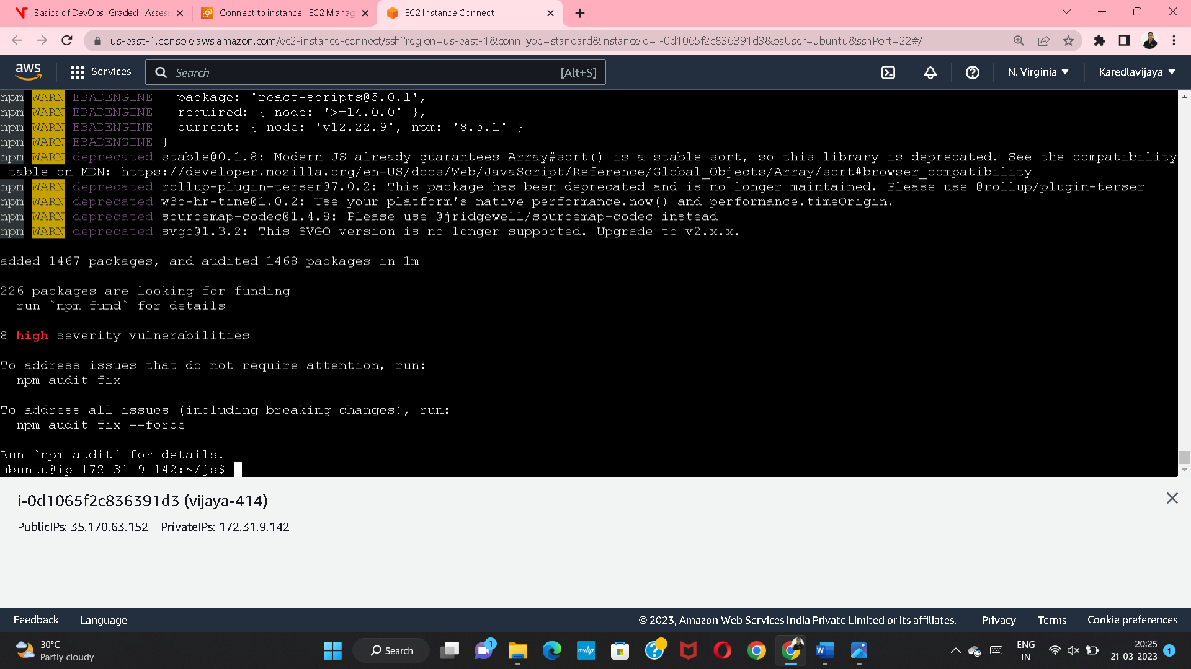

AMAZON REACT VIEW

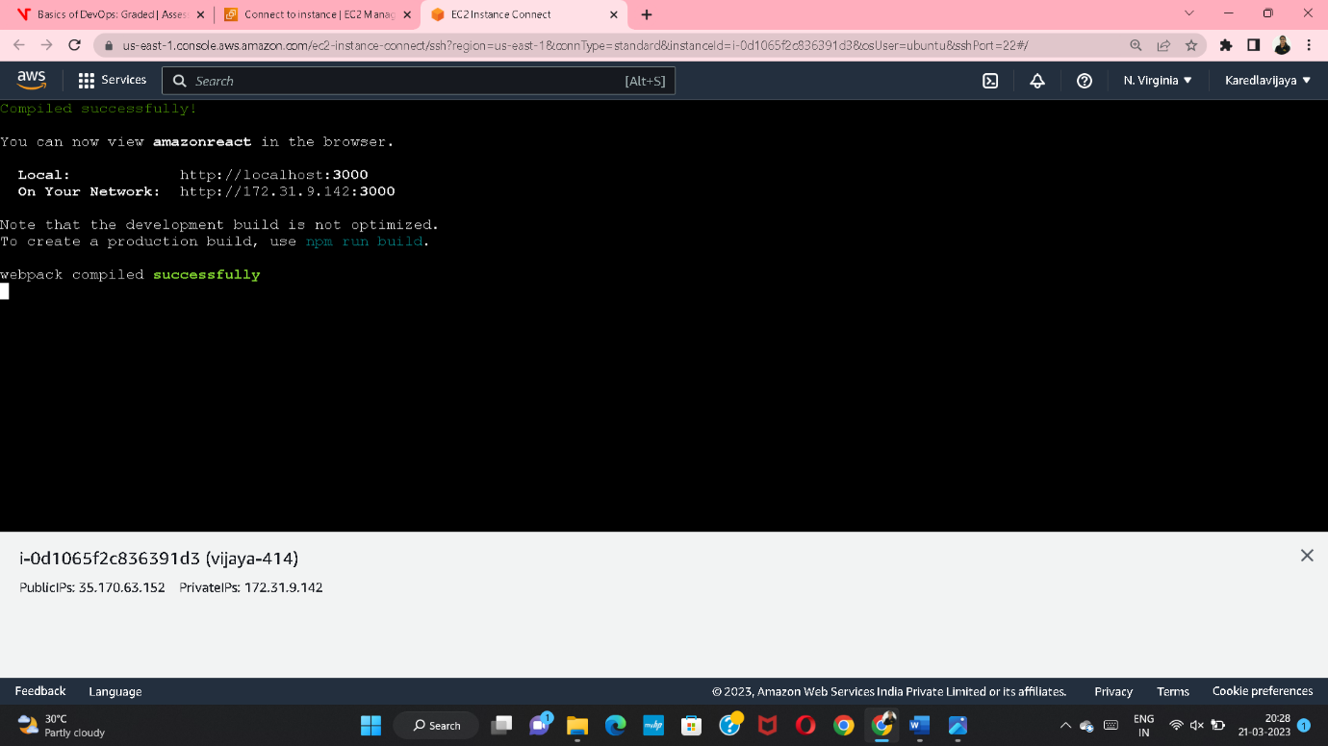

EDIT INBOUND RULES

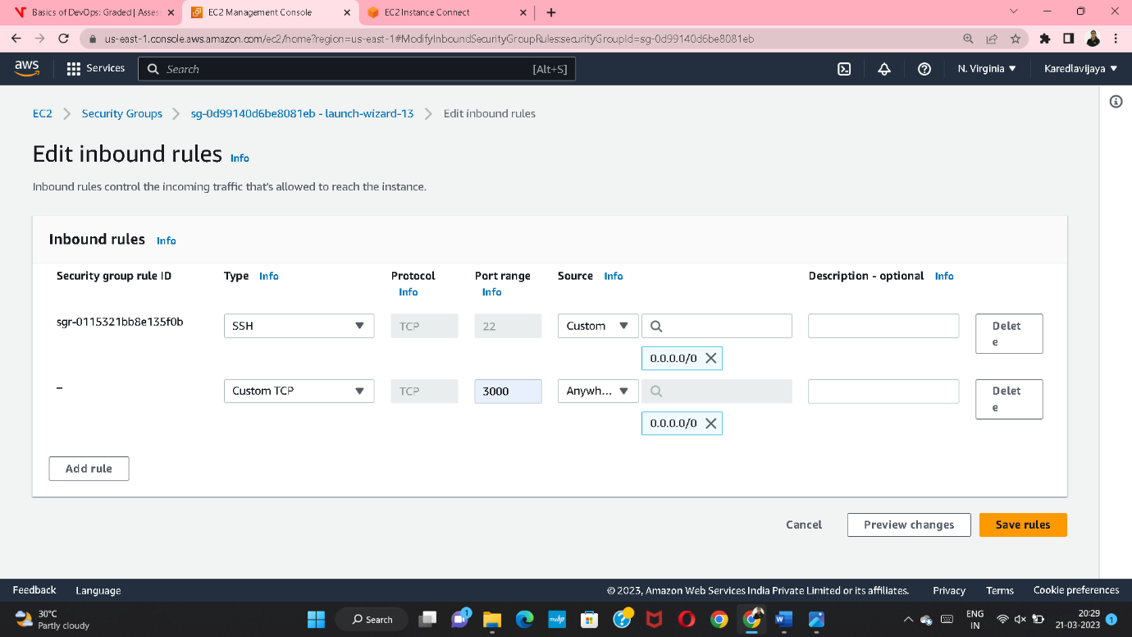

COPY IPV4 ADDRESS

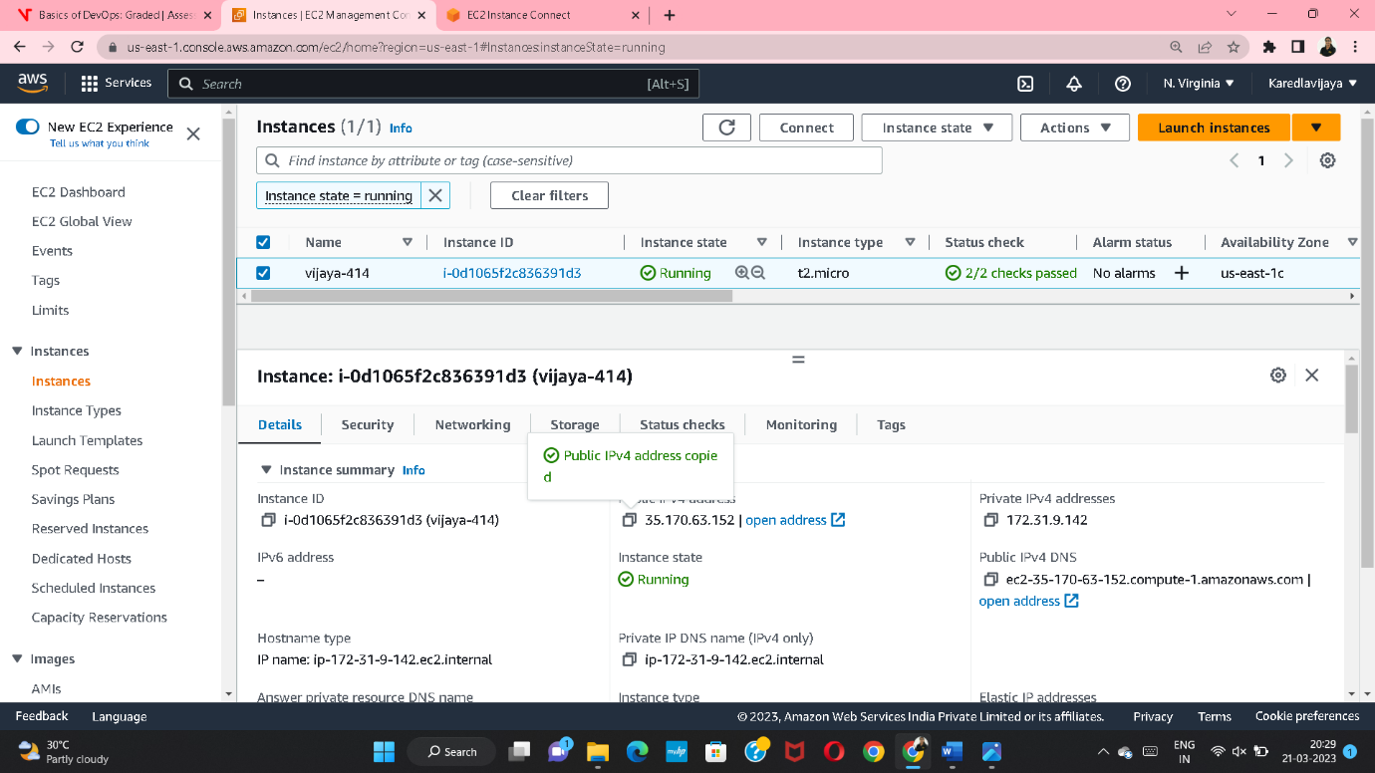

PASTE IPV4 ADDRESS WITH PORT

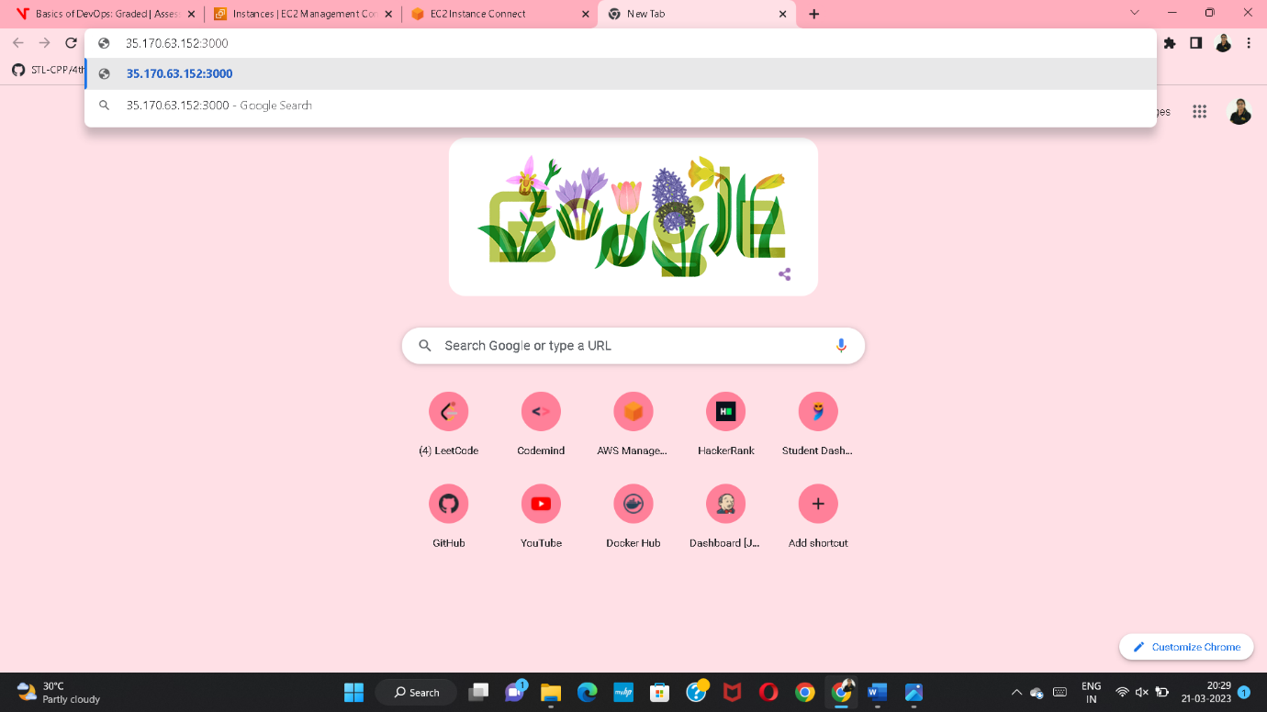

CREATED THE EC2 INSTANCE AND DEPLOYED THE APPLICATION

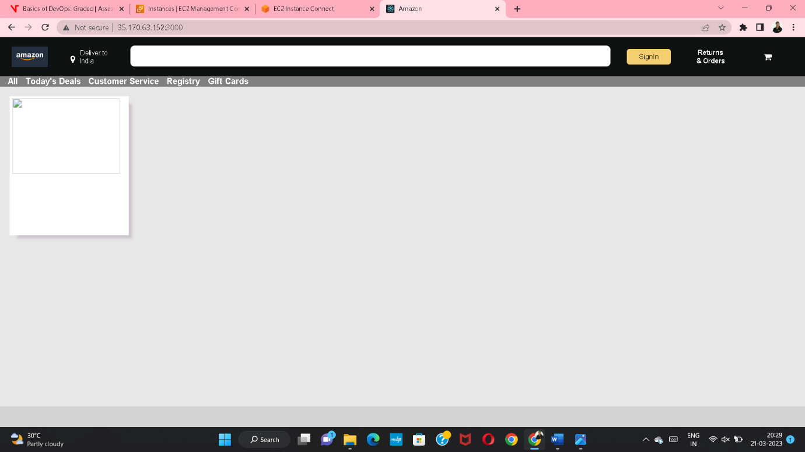

Q3. Create a RDS connection with ec2 instance and use it to create an SQL database and a sample table.

INSTANCE SHOULD BE CREATED WITH UBUNTU IMAGE

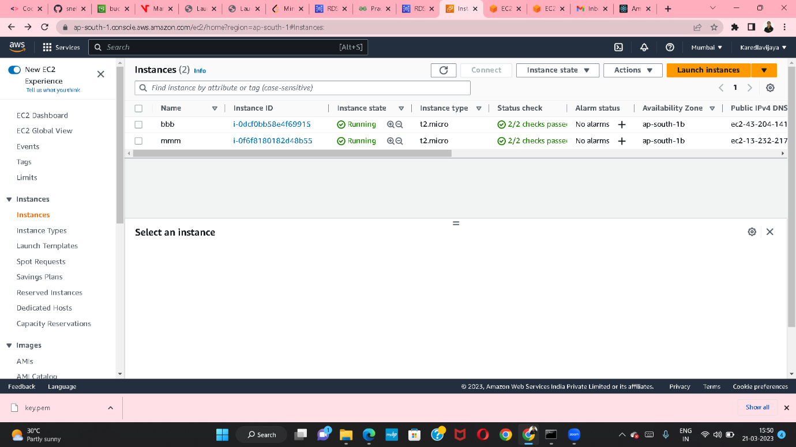

DATABASE SHOULD BE CREATED

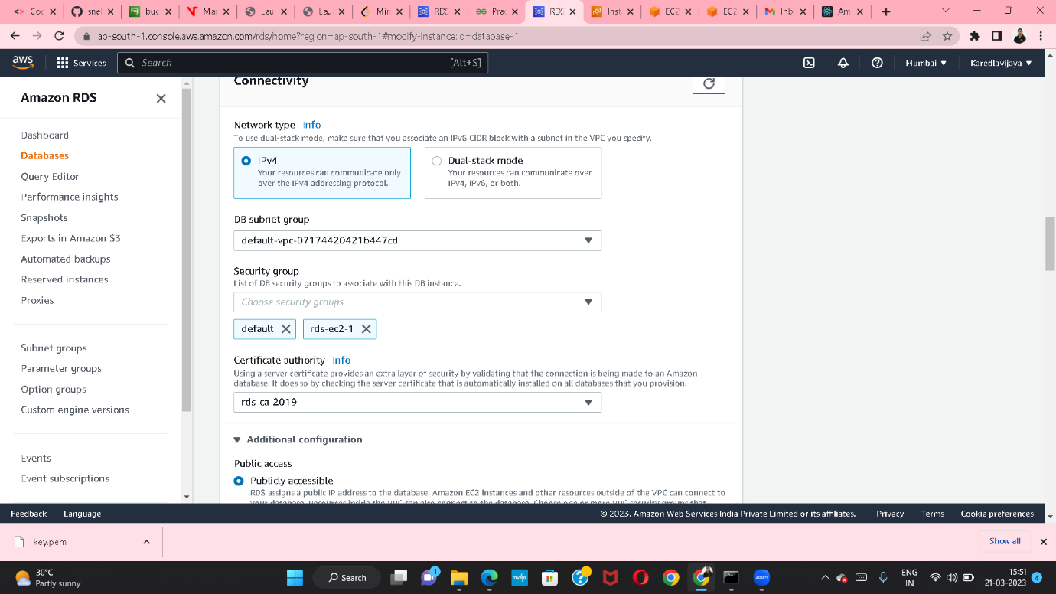

THEN SELECT SECURITY GROUP AND EDIT INBOUND RULES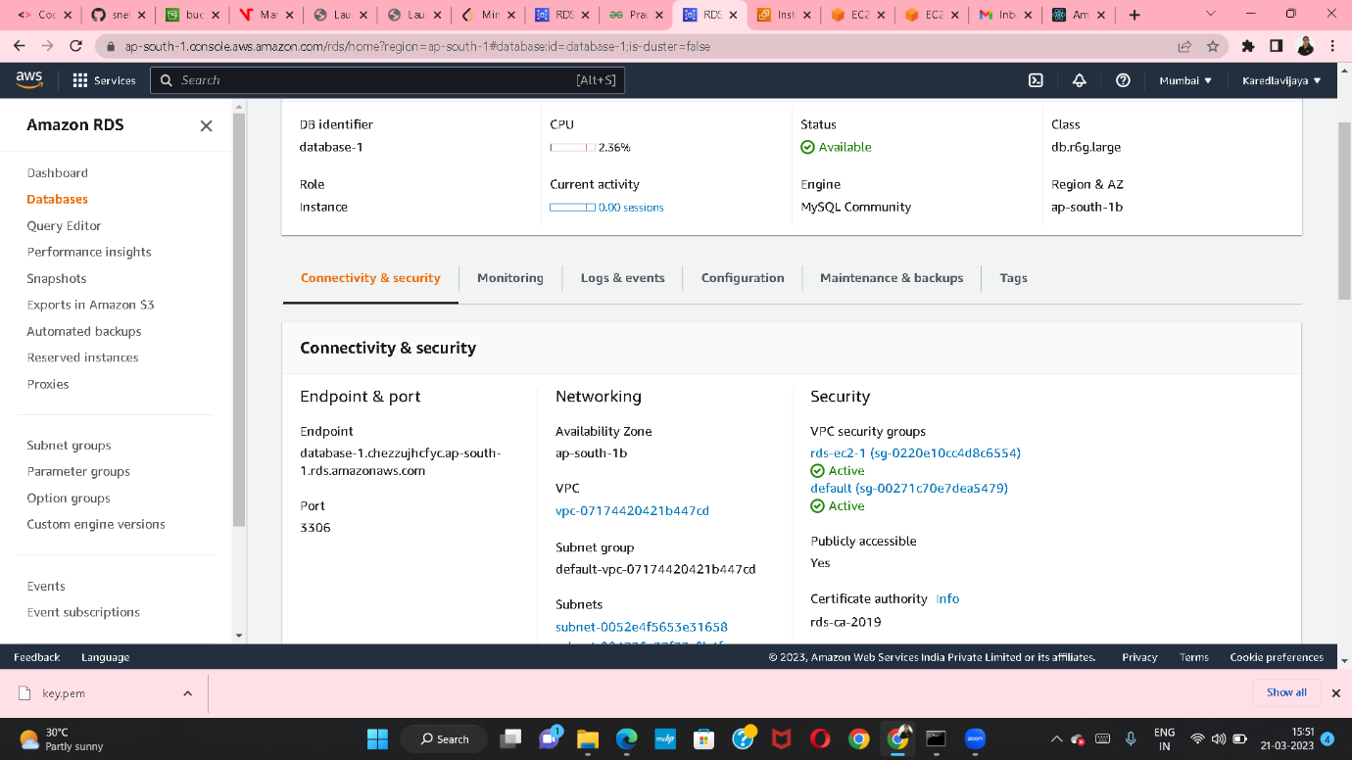

CREATED DATABASE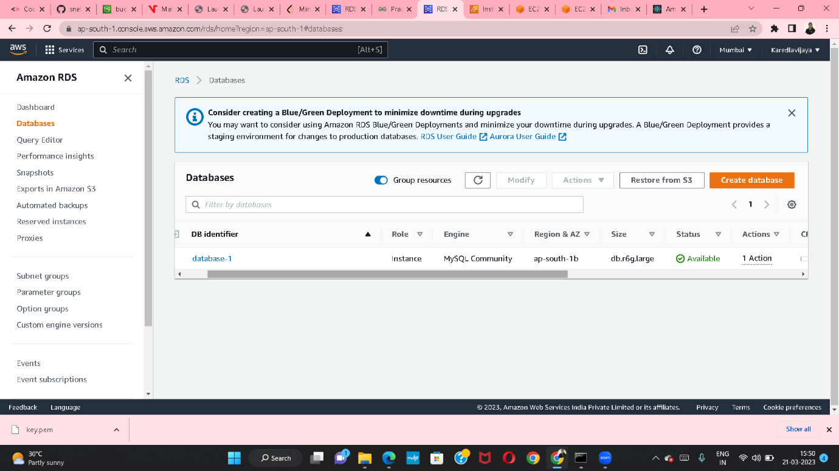

THEN MAKE PUBLIC THE RDS AND SWITCHED TO EC2CONFIGURATION

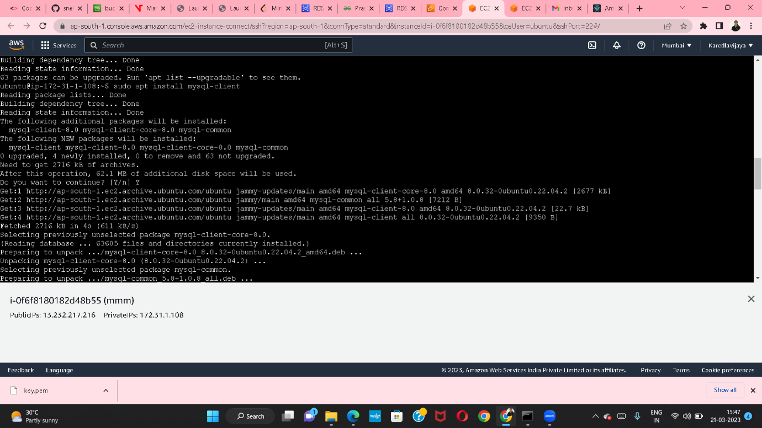

THEN CONNECT THE EC2 INSTANDS AND RUN THE COMMANDS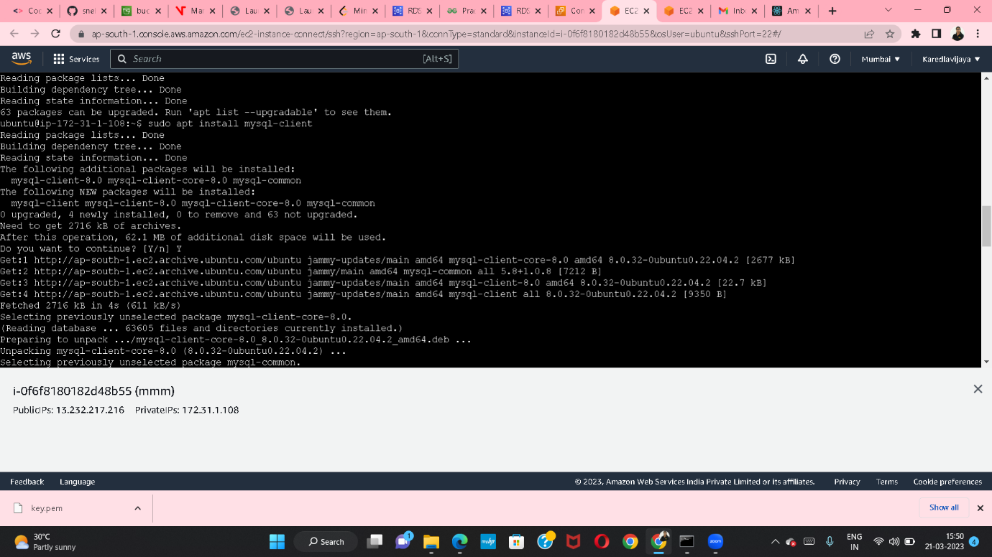

FINALLY CREATE A TABLE USING SQL(Strcutural query language)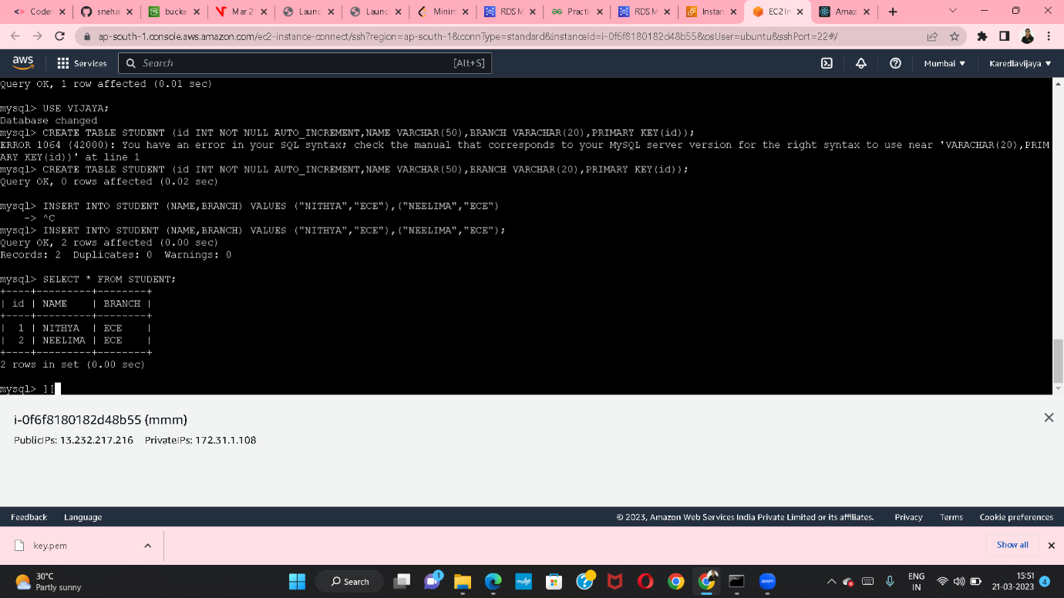

Q4. Create an S3 bucket and deploy the REACTJS static application on it and provide with the public URL for use.

CREATED AN EMPTY BUCKET

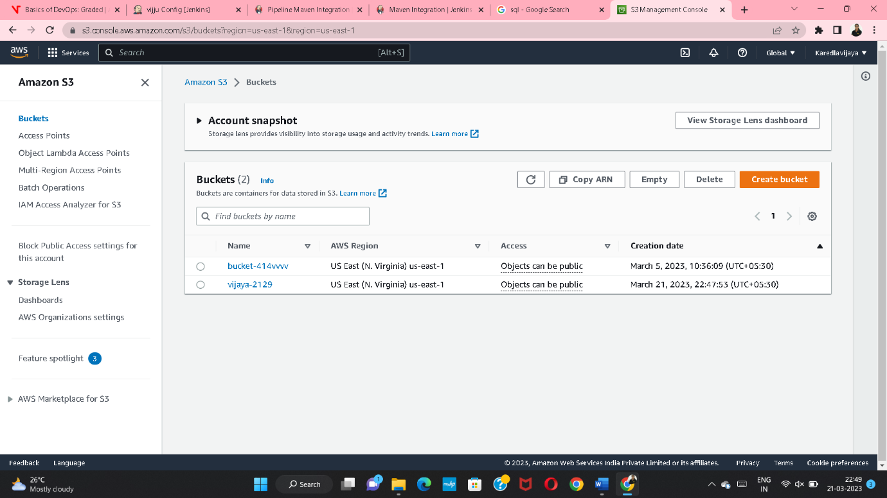

UPLOAD THE OBJECTS INTO THE BUCKET

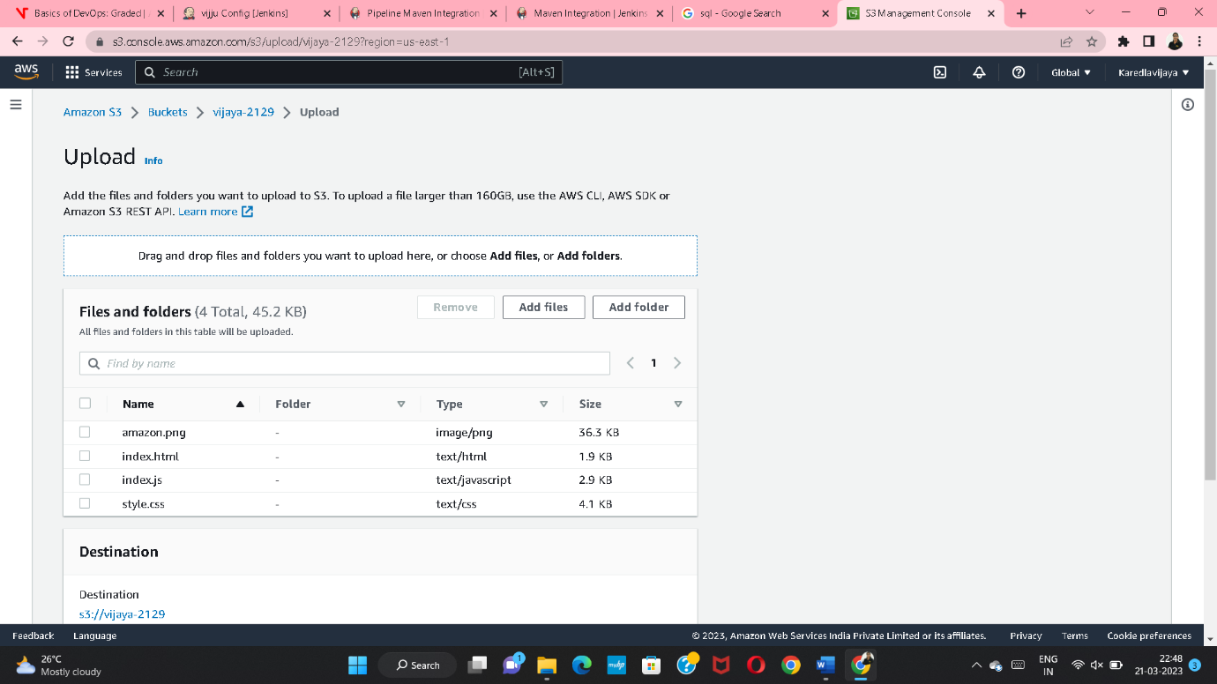

\*CREATE A BUILD FOLDER IN VS CODE

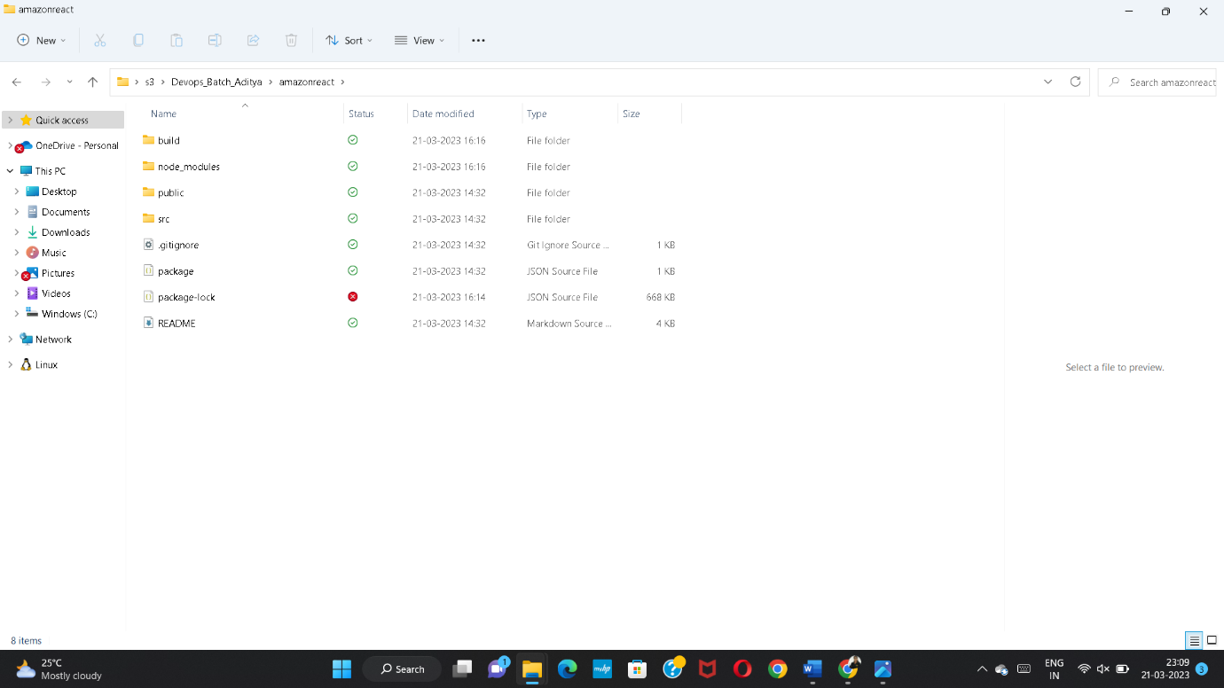

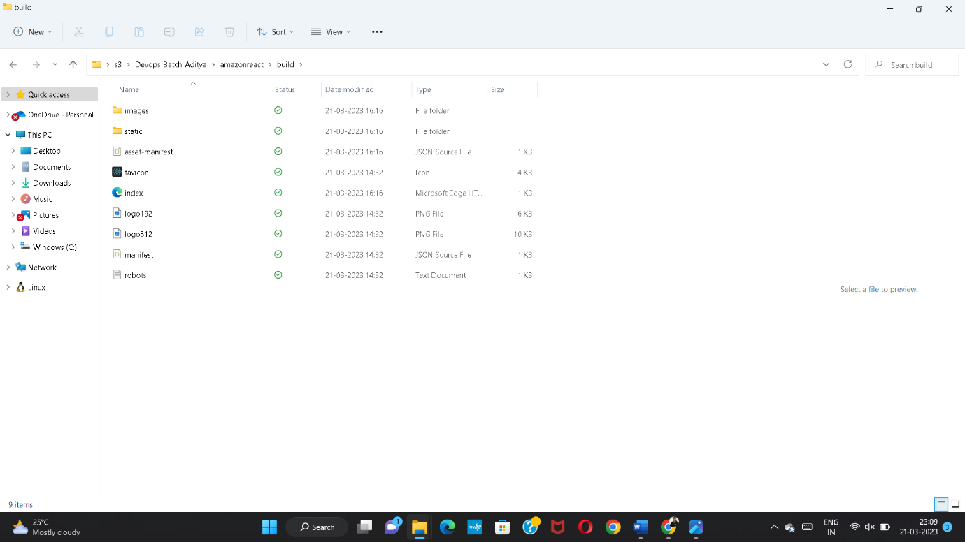

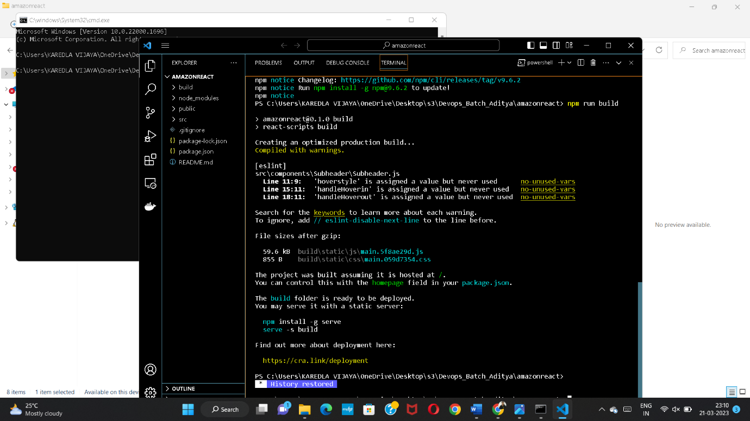

ENABLE STATIC WEBSITE HOSTING,AND MAKE PUBLIC THE OBJECTS

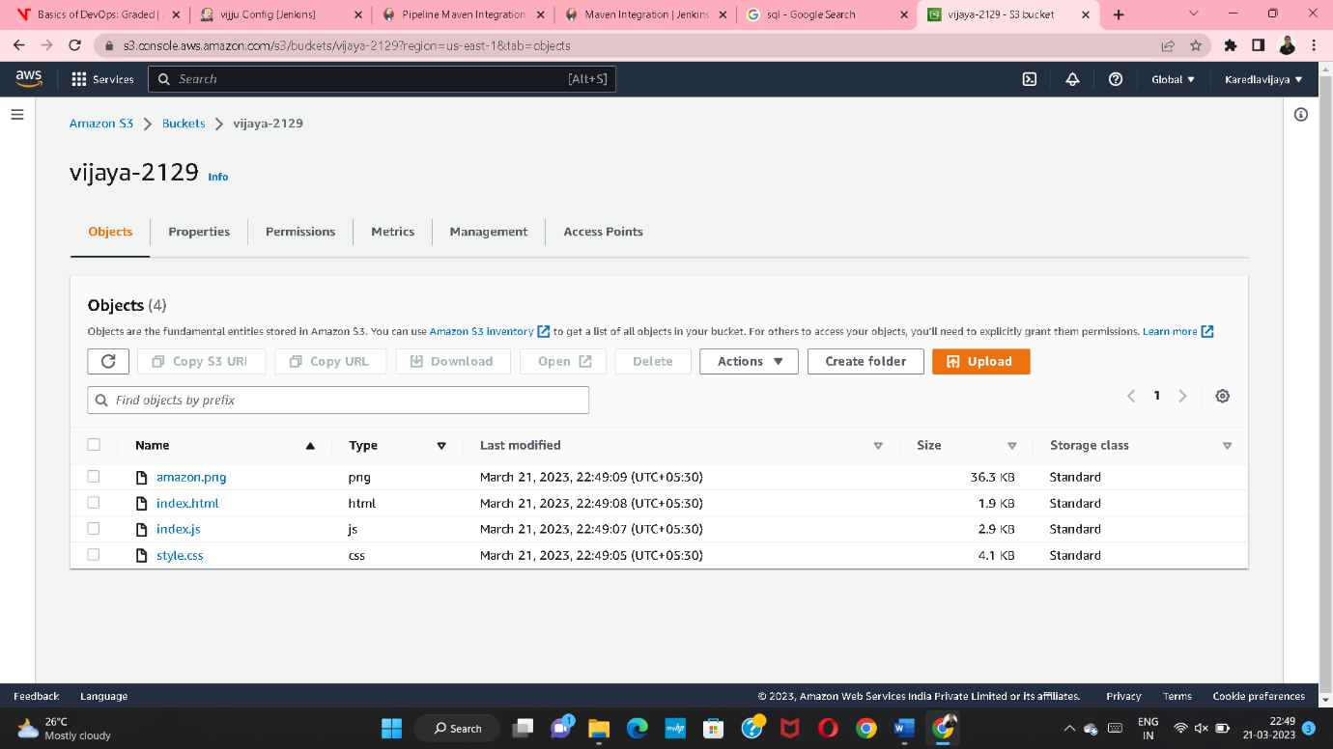

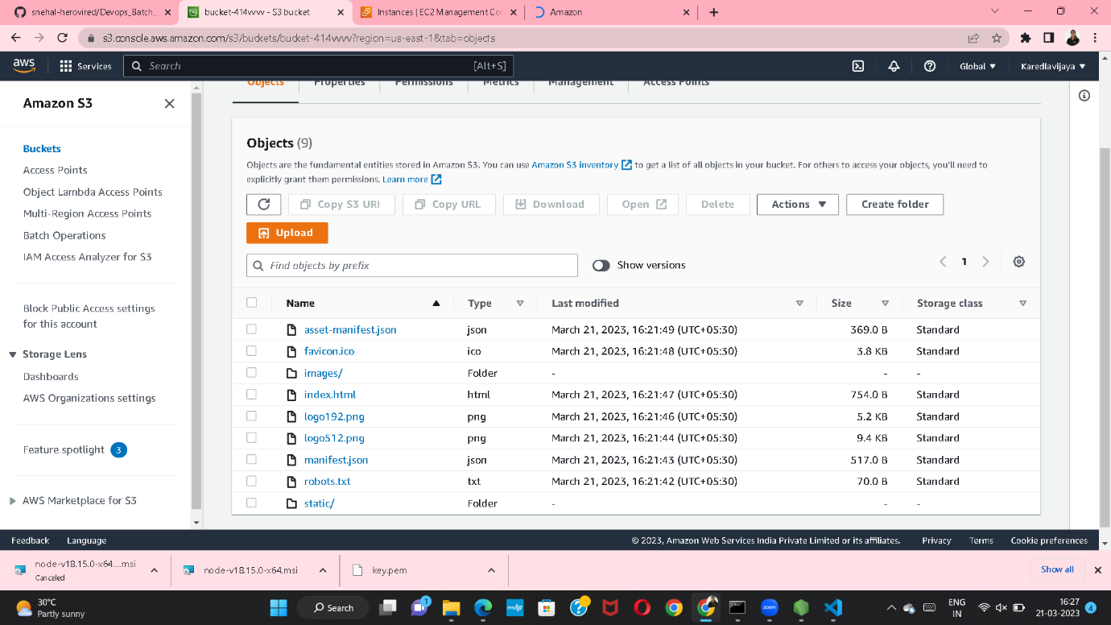

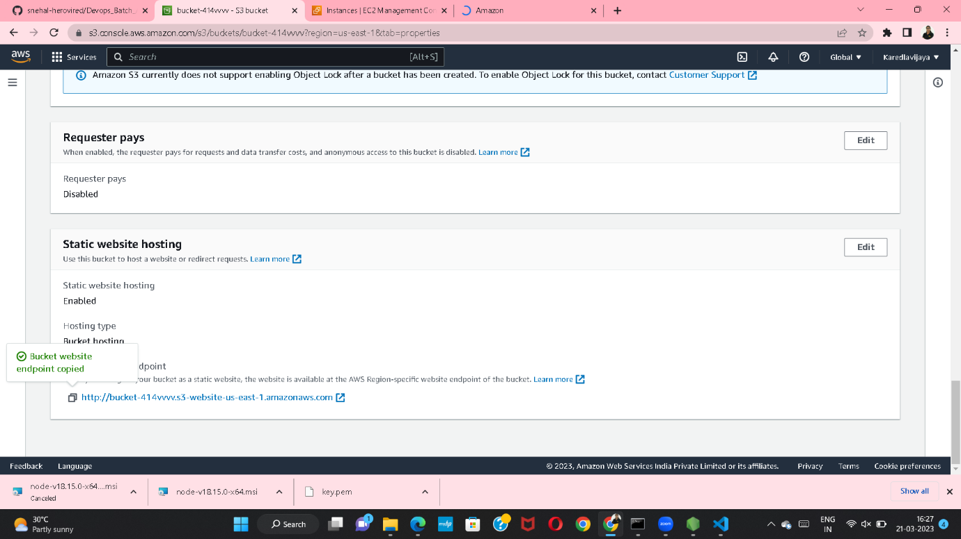

THEN COPY OBJECT URL AND PASTE IN THE NEWTAB

